**EDU_PLATFORM**

Database:  
 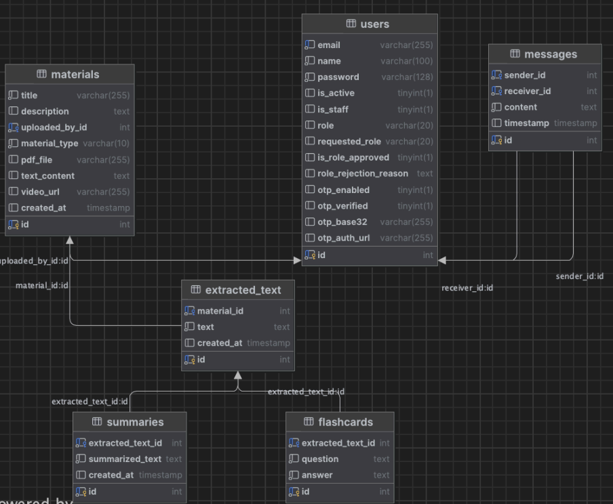

**1. User Management**

* Users can register as **students**, **teachers**, or **admins**.
* Users can log in, log out, and reset their password.
* Users can update their profile information.

**2. Course Management**

* Teachers can create, edit, and delete courses.
* Teachers can upload course materials (videos, PDFs, quizzes).
* Students can browse available courses.

**3. Content Delivery**

* Students can view or stream videos, read documents, and access course materials.
* Content is released based on schedules or progress tracking (e.g., drip content).

**4. Assessment and Quizzes**

* Teachers can create flashcards or assignments.
* Students can take flashcards and submit assignments.
* Automatic or manual grading is supported.
* Students can view their results and feedback.

**5. Communication Tools**

* Teachers and students can exchange messages

**6. Progress Tracking**

* Students can track their course progress.

**7. Admin Dashboard**

* Admins can manage users, courses, and reported content.
* Admins can monitor platform usage and generate reports.

